Assumptions of Logistic Regression — Cyber Phishing Screen
Security adaptation of the Codecademy LR-assumptions lab · short name: LogReg_Cyber

Problem Statement
A SOC must score inbound URLs as phishing or benign from a short feature card (length, subdomains, raw IP, HTTPS, digit ratio). Phish is the minority class (243 / 720) and a miss reaches a human inbox. Before the classifier ships we check logistic assumptions, then pick an operating threshold that puts catch-rate ahead of ticket volume.

Solution Strategy
1) Encode PHISH/BENIGN as 1/0 and confirm one row per event_id. 2) Cap features by the 10-EPV rule (243/10 = 24.3). 3) Screen outliers on log-z boxplots; drop extreme redirect_count. 4) Drop path_length (r ≈ 0.97 with url_length) and request_hour (flat logit). 5) Fit an unregularized 5-feature logit. 6) Sweep the decision threshold, draw the ROC, compare default vs stratified vs class_weight='balanced'. 7) Transfer the same workflow to a brute-force login file and stress-test n, noise and threshold.

Solution
Hold-out (random_state=0, 30%): accuracy ≈ 0.81, precision ≈ 0.77, recall ≈ 0.65, F1 ≈ 0.71, AUC ≈ 0.87. Confusion at t=0.50: TN 123 / FP 15 / FN 27 / TP 51. Lowering the cut to 0.25 cuts missed phish to 7 and raises extra tickets to 46 — the gateway direction of travel. Dummy most-frequent AUC = 0.50.
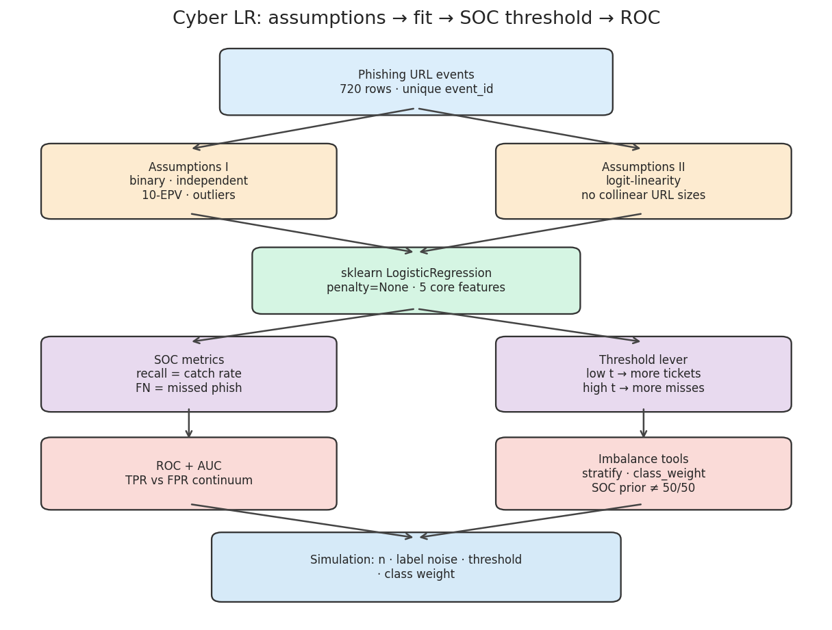
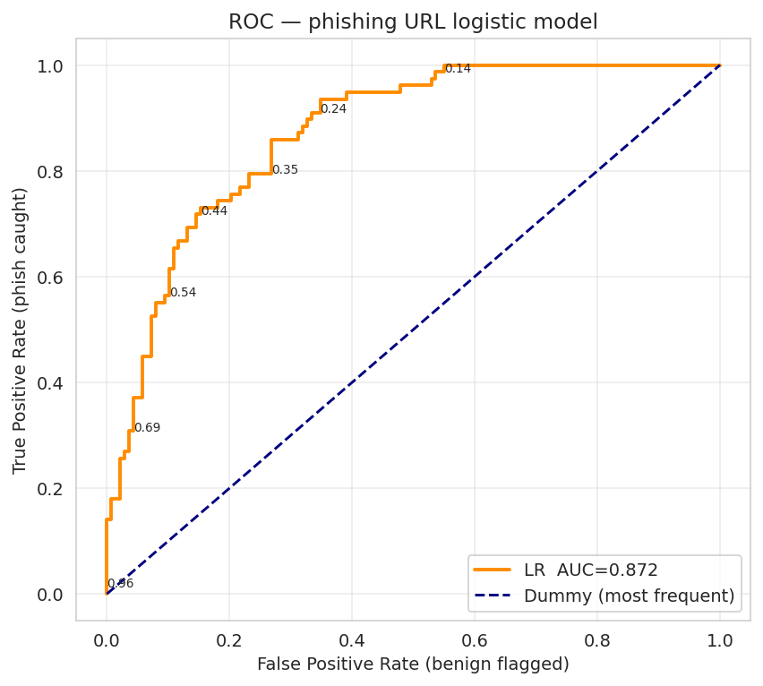
Left: assume → fit → SOC threshold → ROC / imbalance. Right: ROC vs a most-frequent dummy. Sit on the upper-left of the curve (t ≈ 0.25) when a miss costs more than a ticket.

Key Takeaways
- Do not put url_length and path_length in the same scorecard — they are the same size signal twice.
- Accuracy is flattering here because most URLs are benign. Quote catch-rate, FN count and tickets-per-hour.
- t = 0.5 is a library default, not a CISO policy. Move it until the miss budget is met.
- class_weight='balanced' lifts catch-rate when the SOC prior is not 50/50.
- This is a first-pass risk score, not a verdict and not a causal model of “why phishing happens”.

